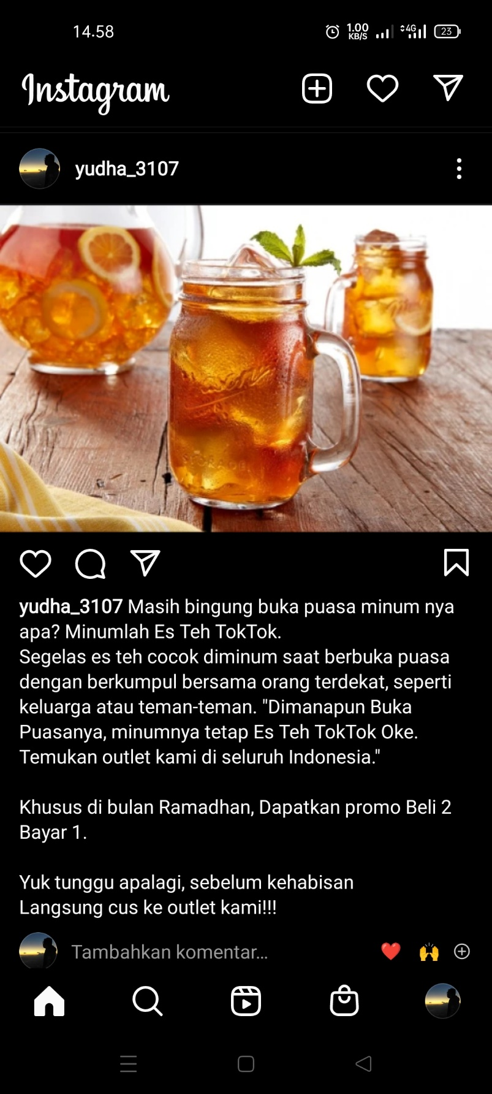

<https://www.instagram.com/p/Cc2NDPTvZah/?igshid=YmMyMTA2M2Y>=